**Chronotron**

<https://www.kongregate.com/games/Scarybug/chronotron>

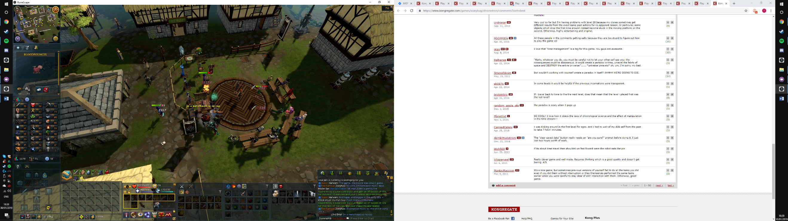<https://www.kongregate.com/games/scarybug/chronotron/comments?sort=best>

Players wish to be challenged mentally when solving puzzles.

Players have a lot of problems with bugs in games like this.

**Fancy Pants Adventure World 2**

<https://www.kongregate.com/games/DrNeroCF/fancy-pants-adventure-world-2>

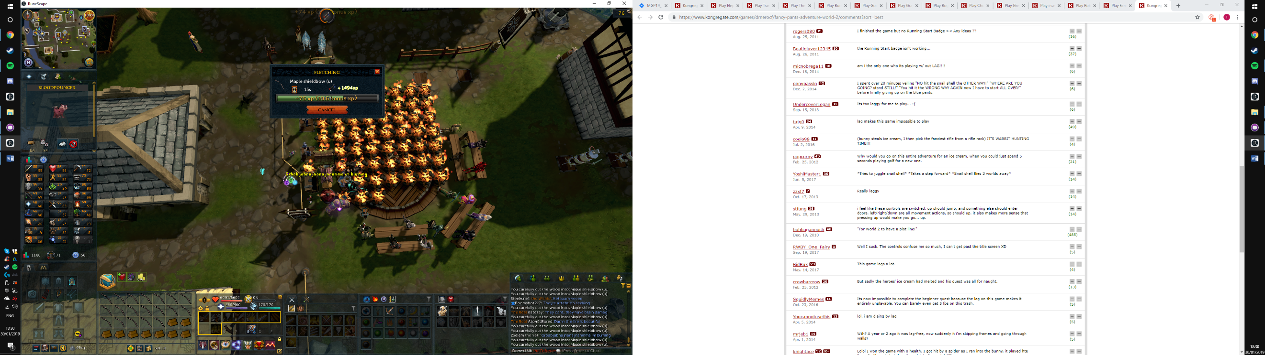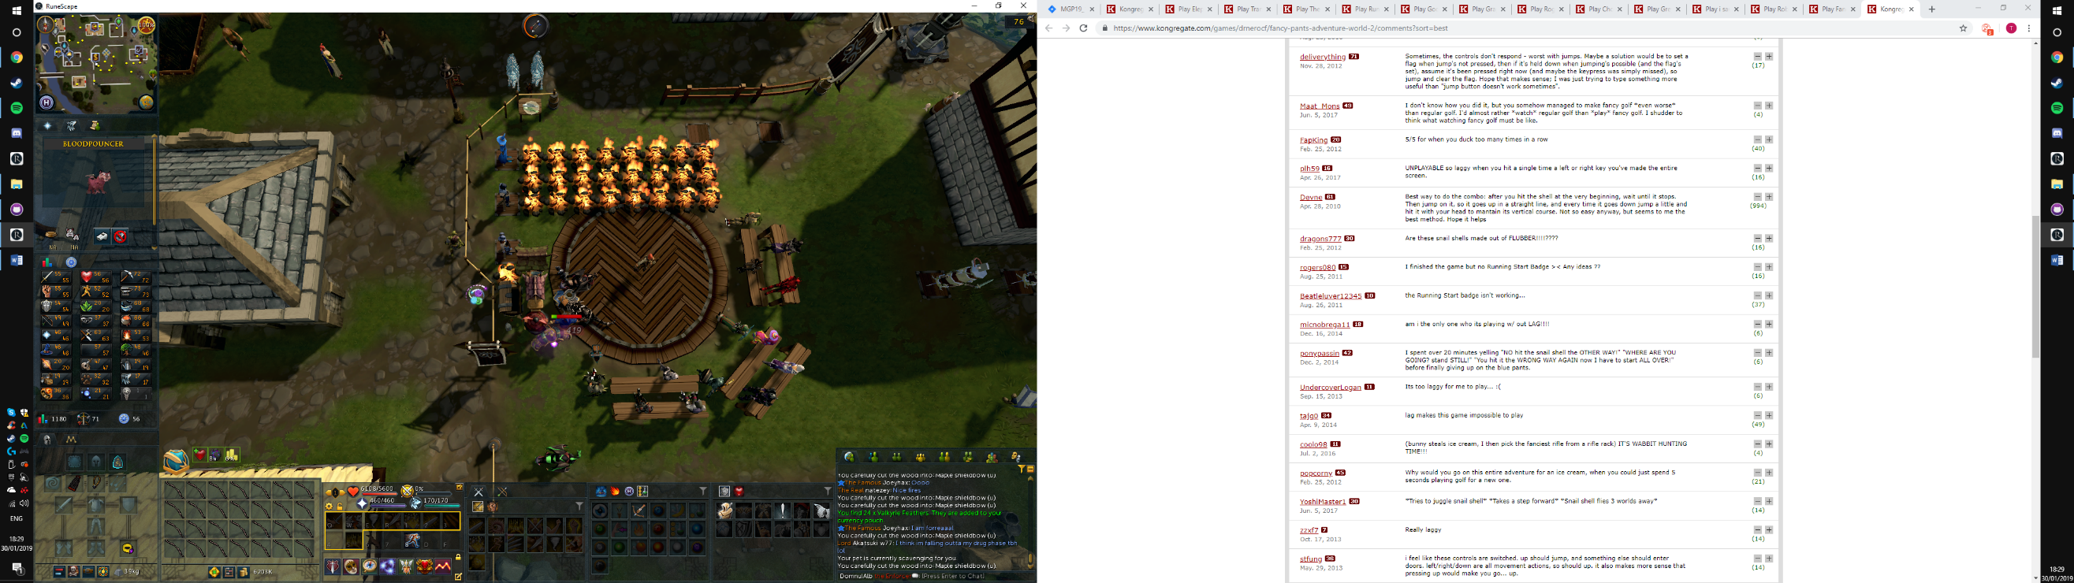<https://www.kongregate.com/games/drnerocf/fancy-pants-adventure-world-2/comments?sort=best>

Players wish to be challenged and are likely to be frustrated.

Players wish to experience a well optimised game

Players wish to encounter intuitive controls

**Grey**

<https://www.kongregate.com/games/kevindoesart/grey>

<https://www.kongregate.com/games/kevindoesart/grey/comments?sort=best>

Players like being able to find their own meaning behind the narrative of games

**Choppy Orc**

<https://www.kongregate.com/games/eddynardo/choppy-orc>

<https://www.kongregate.com/games/eddynardo/choppy-orc/comments?sort=best>

Players want a core mechanic to be satisfying and interesting.

Players want skill combined with puzzles

**Elephant Quest**

<https://www.kongregate.com/games/ArmorGames/elephant-quest>

<https://www.kongregate.com/games/armorgames/elephant-quest/comments?sort=best>

Players don’t want total realism

Players want creative freedom around the choices they make